A Japanese Perspective on CBAM and Carbon Pricing

@Bruegel
Toshi H. Arimura

RIETI, Waseda University, RIEEM, Paris School of Economics May 22nd, 2024

This study was conducted as a part of the project “Studies on Transformations of International Systems and Their Impact on Japan’s Mid- and Long-Term Competitiveness” undertaken by the Research Institute of Economy, Trade and Industry (RIETI). It was supported by JSPS KAKENHI Grant Number JP21H04945.
RIETI/Waseda University, Toshi H. Arimura

Summary of EU CBAM
- EU Commission announced the implementation of a CBAM in July 2021
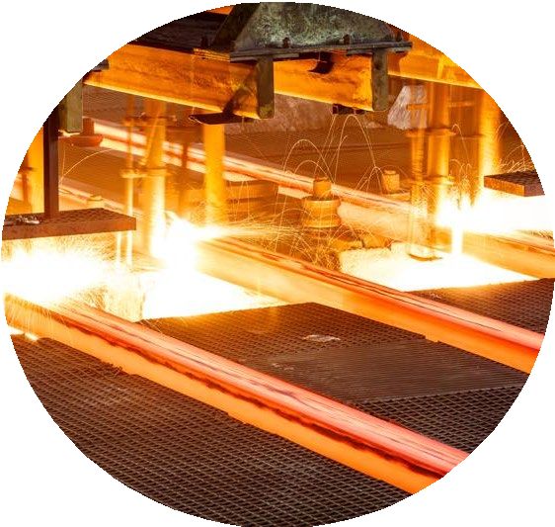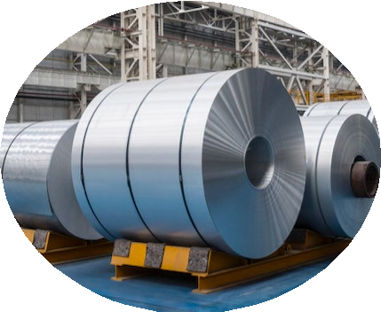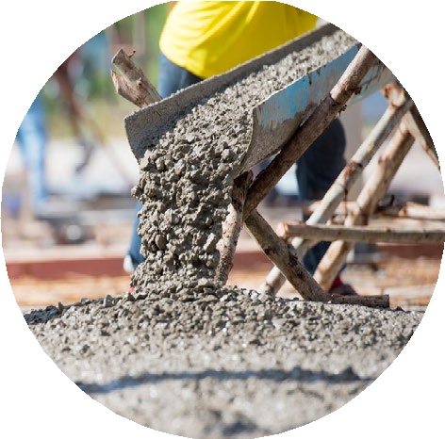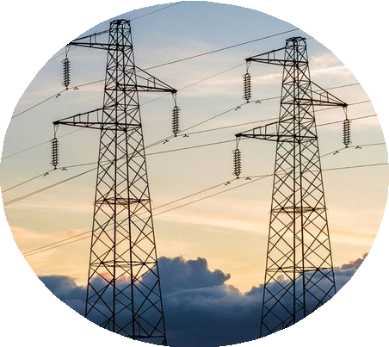

Iron and Steel
Aluminium
Chemicals
Cement
Electricity
- The proposal was revised by the EU Parliament, and accepted in June 2022
- Exporters to EU will have to pay a carbon price at the border (importers purchase certificates), the value of which will be determined based on the embodied emissions of their product as well as the level of carbon pricing paid in the country of origin.
- A pilot period started from October 2023 and exporters will have to start paying from 2027 (discounted payment until 2032 when free allowances end in the EU ETS)
- A controversial policy, the EU CBAM has been criticized as a form of climate protectionism by BRICS members and it is unclear whether the EU proposal abides by the rules of the WTO.

Waseda University, Toshi H. Arimura 2

Two Impacts of EU CBAM

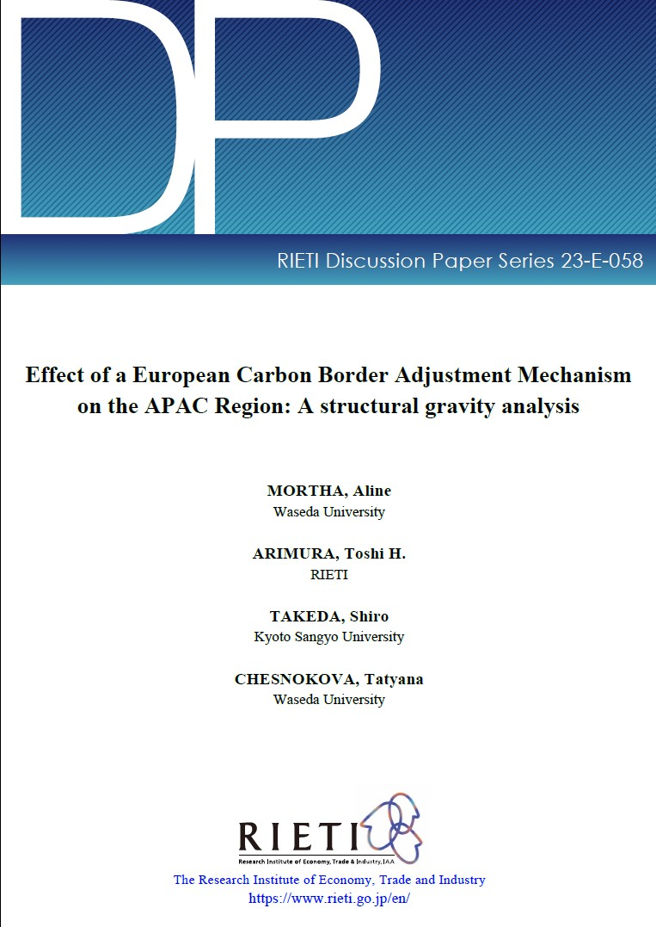Direct Economic Impacts
Economic Analysis of CBAM by Structural Gravity Model
– Impacts on Japan and Asia using a structural gravity model.

Indirect Impacts: Carbon Pricing around the world after CBAM

https://www.rieti.go.jp/en/publicati ons/summary/23080002.html
Waseda University, Toshi H. Arimura 3

Changes in exports from China
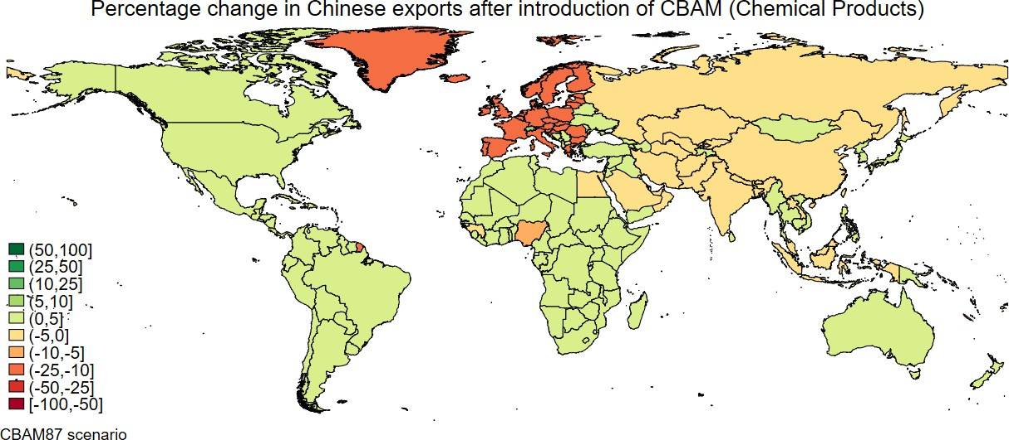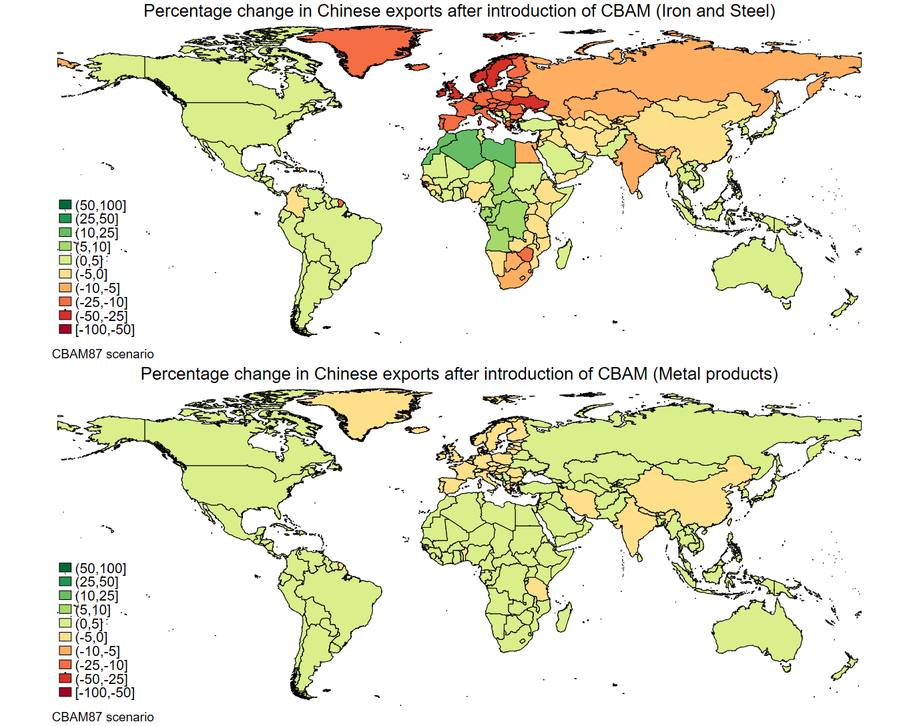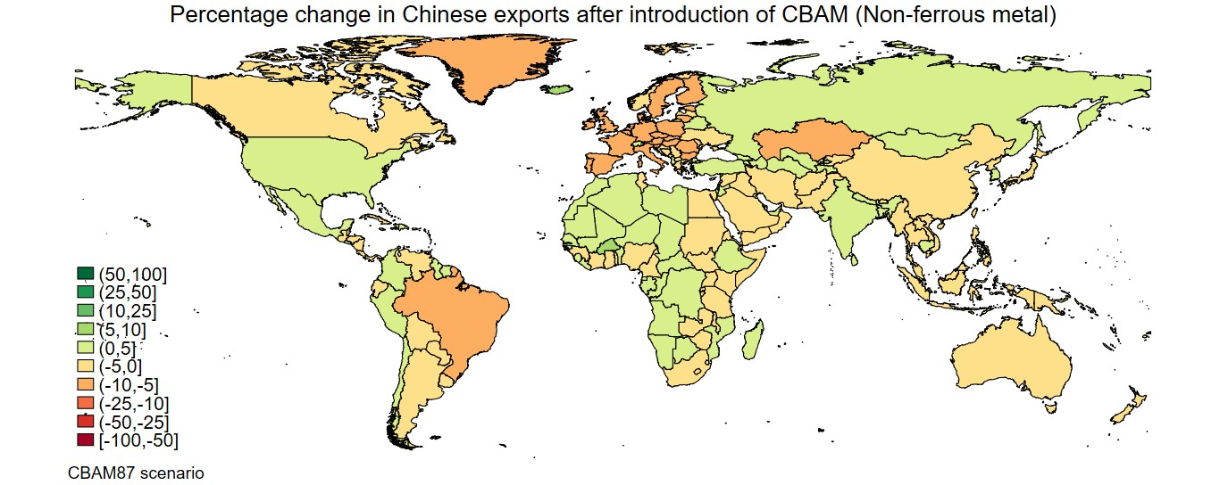(CBAM 87€)
Negative Impacts on Developing
Economies in general
Chemical Products
Steel

Export to EU will be reduced.

Metal Products
Non-ferrous Metal
Mortha, Arimura , Takeda and Chesnokova (2023)

Waseda University, Toshi H. Arimura 4

Changes in exports from Japan

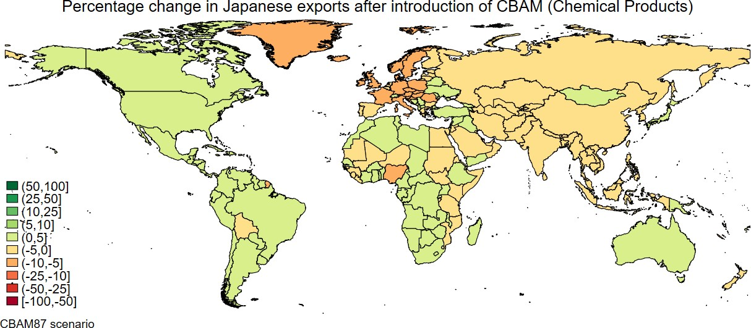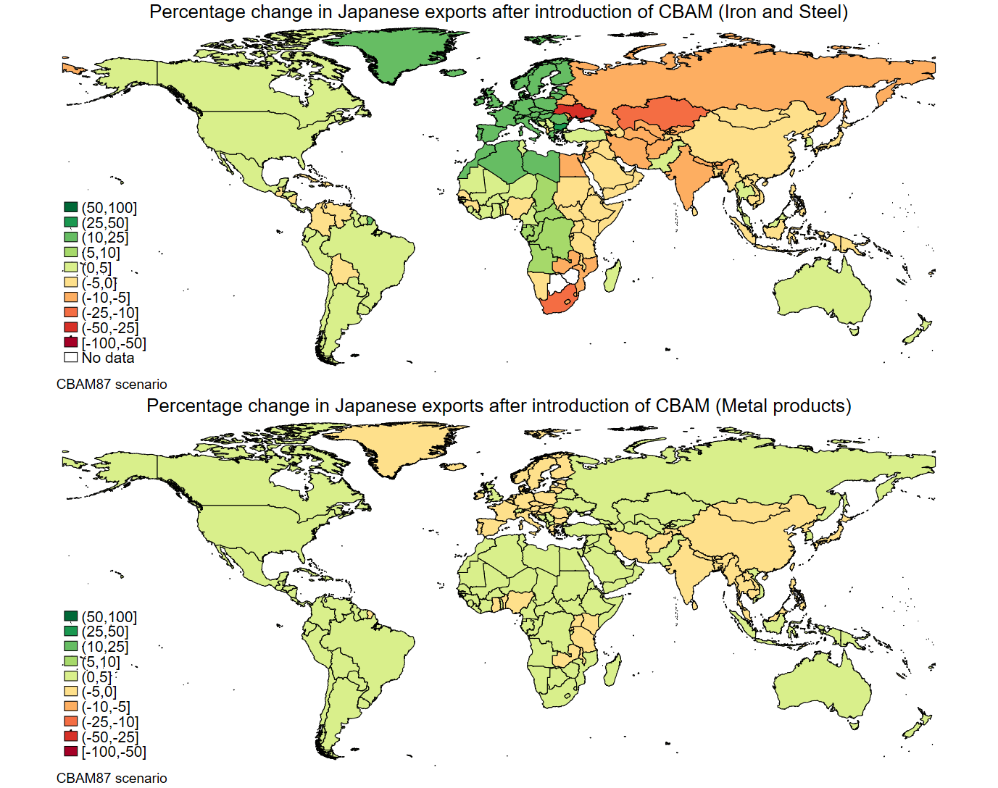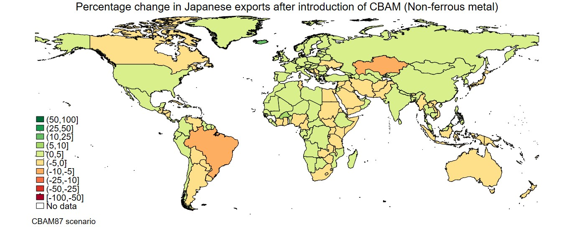(CBAM 87 €)
Chemical Products
Positive Impacts on Some
Developed Economies

Steel

Japan my gain in EU Trade from CBAM

Metal Products
Non-ferrous Metal
Mortha, Arimura , Takeda and Chesnokova (2023)

Waseda University, Toshi H. Arimura 5

Carbon Pricing around the world

Before and after CBAM

6

Japanese Carbon Pricing before CBAM (1)

- Regional Emissions Trading Schemes in Tokyo (2010-) and Saitama (2011-)

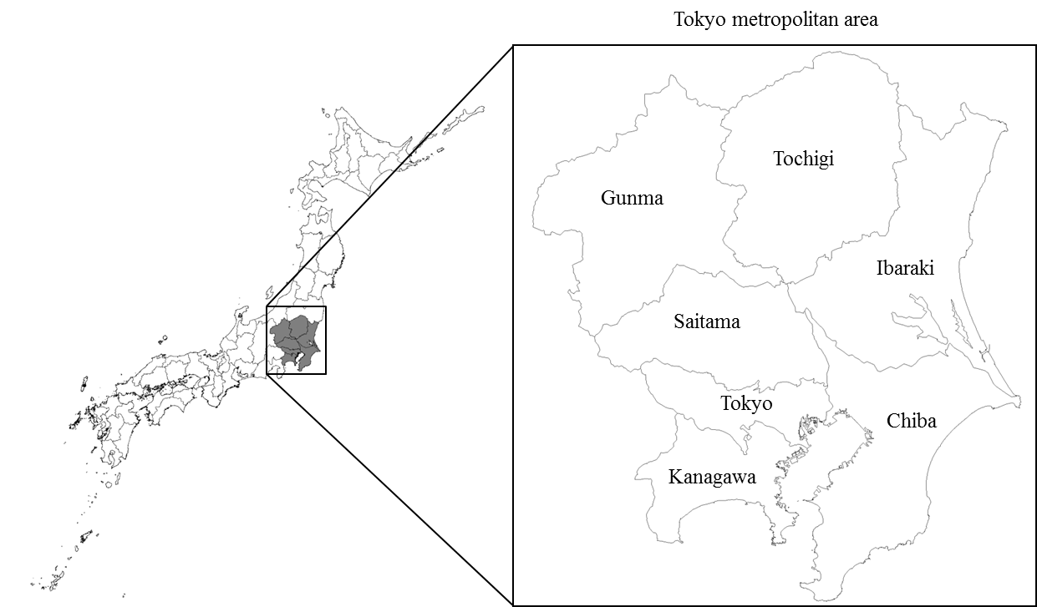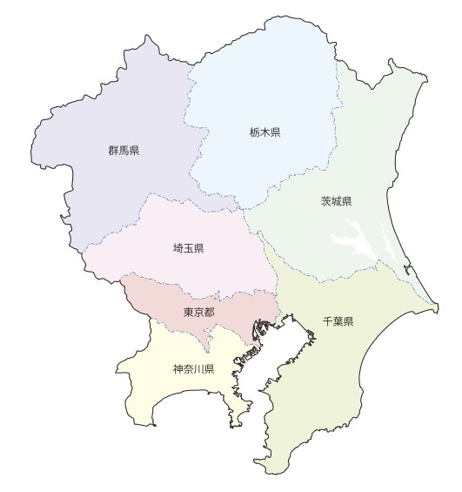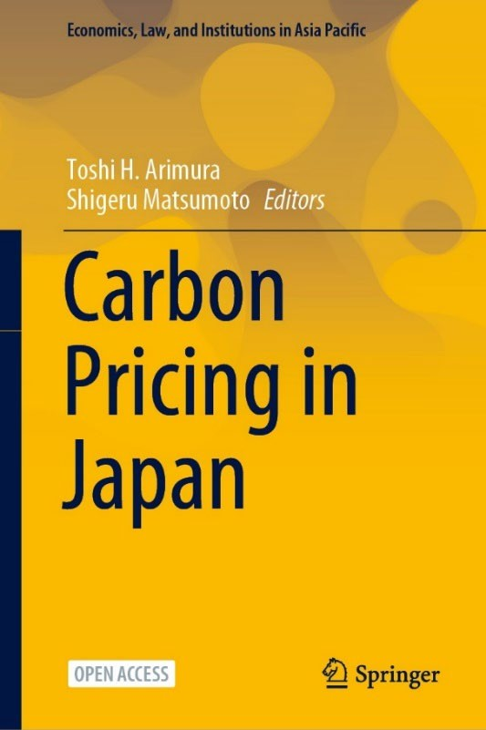ETS

ETS

Saitama

Tokyo

Arimura & Matsumoto Ed.

7

Japanese Carbon Pricing before CBAM (2)

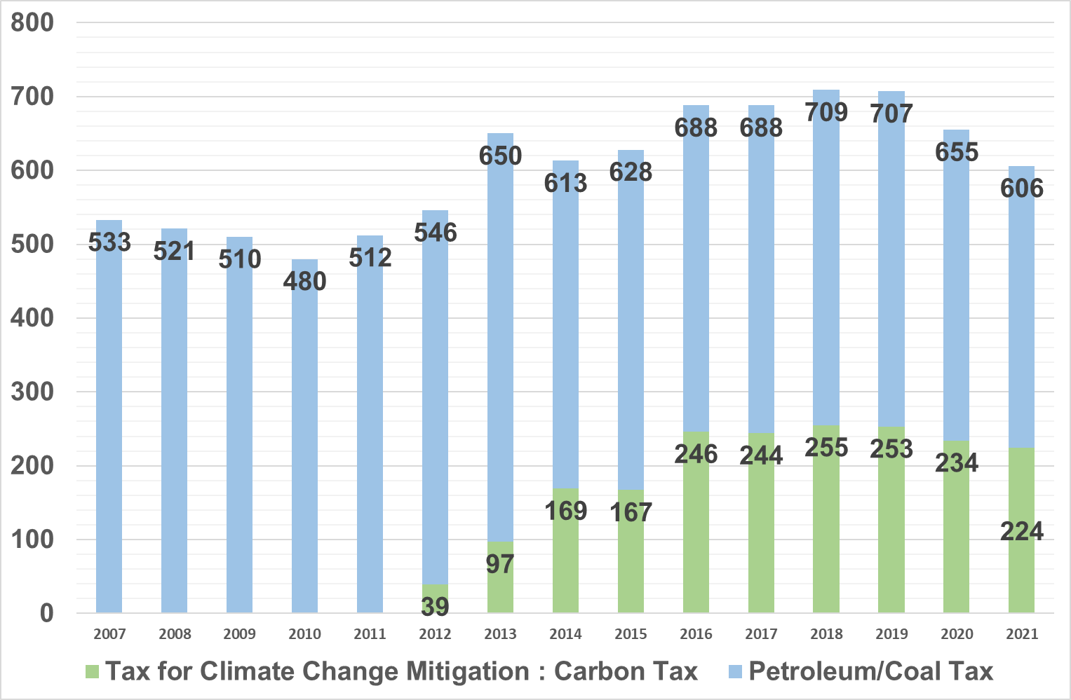Carbon Tax at the national level (2012-)

Carbon Tax Revenue
Carbon Tax Revenue (Billion Yen)
- 289 yen per CO2 ton (<<2 €)

The revenue is used for energy- related innovation

Source: Japanese Ministry of the Environment
8

Reaction to CBAM?
Green Transformation (GX) Act in Japan
- Japan Climate Transition Bond (2023-)

Funding for R&D and Innovation（2 trillion yen in 10 years)
- Carbon Pricing

An Emissions Trading Scheme (GX-ETS)
  - Phase I: 2023-2025 (Though voluntary, required for access to the GX bond. Covers more than 50 % emission)
  - Phase II: 2024- (Mandatory) (Planned)
  - Auction after 2033 in the power sector (Planned)

Carbon Surcharge （carbon tax）
- Charges on the imported fossil fuels (similar to current oil and petroleum tax) after 2028 9

Overview of carbon pricing implementation in the world

Carbon tax implemented or planned

ETS or carbon tax considered

ETS implemented or planned

ETS and carbon tax implemented
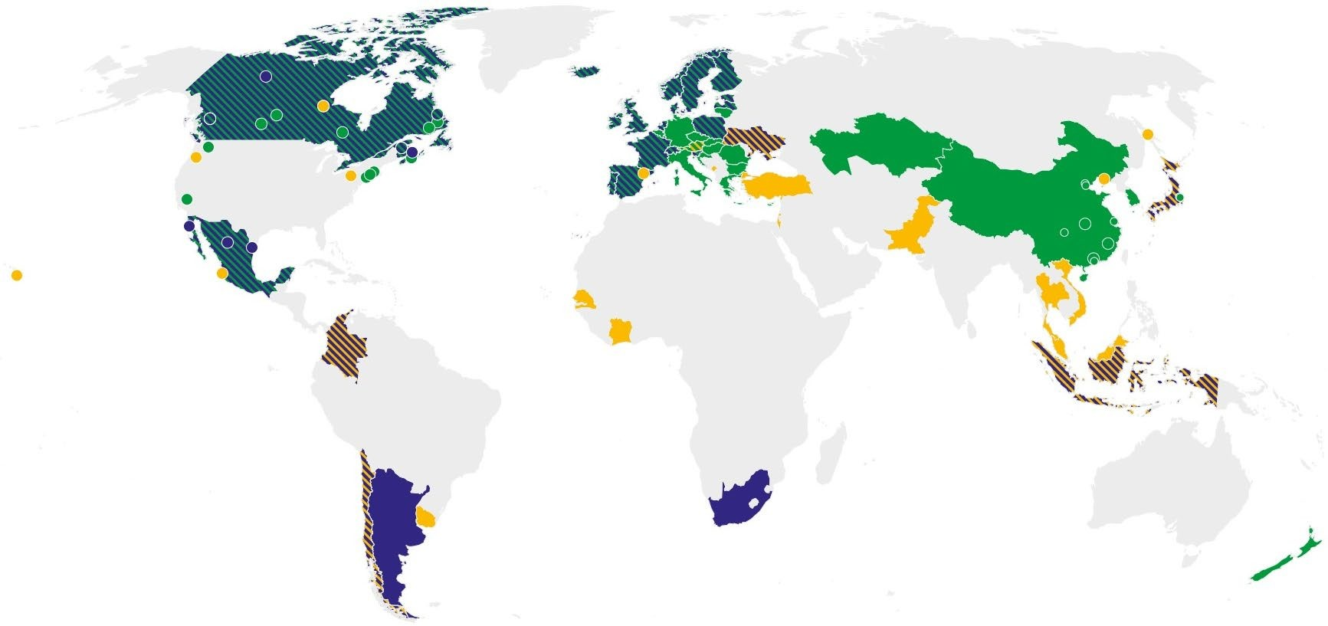EU ETS
ETS implemented or planned; carbon tax considered

Carbon tax implemented or planned; ETS considered

Korean ETS

ETS only in Tokyo and Saitama

California ETS
Carbon tax

RGGI
(Power)

ETSs in Turkey

Chinese ETS (Power)

GX in Japan

CPs in ASEAN

Carbon tax (Chile)
Carbo炭n 素tax税(Singapore, South Africa)

From: The World Bank, Carbon Pricing Dashboard, https://carbonpricingdashboard.worldbank.org/map_data 10

Changes in exports: China
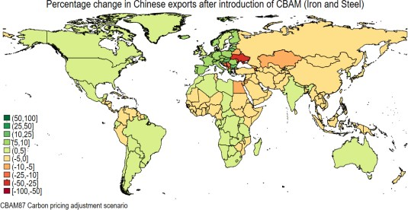(CBAM87 € with CP adjustment in G20)
China may recover export to EU

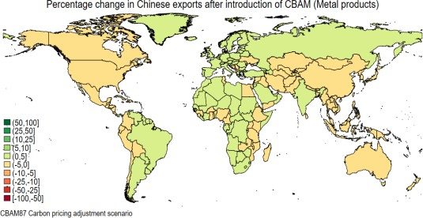
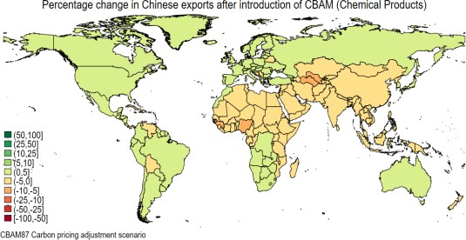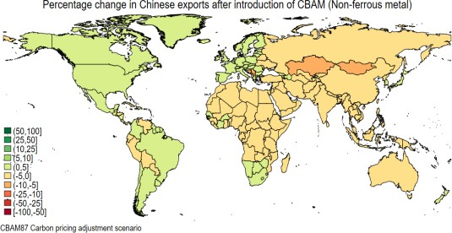

Mortha, Arimura , Takeda and Chesnokova (2023)

Waseda University, Toshi H. Arimura 11

Overall Impacts of EU CBAM

Vulnerability to the policy depends on the level of development
  - High-income economies increase their exports to the EU (comparative advantage).
    - Wider the North/South gap?

Middle-income economies reduce their exports to the EU (and redirect to Africa)
  - CBAM might effectively tackle carbon leakage concerns in EU

EU CBAM is likely to contribute to emission reduction through the promotion of carbon pricing in other parts of the world
  - Japanese GX Policy

Turkey, ASEAN countries…

Waseda University, Toshi H. Arimura 12

Thanks!

Arimura@waseda.jp

